A Project Report

On

**Application of Reliability Models to Experimental Data**

BY

**M.SAI RAGHAVA VIHAR**

**2019A2PS0849H**

Under the supervision of

**Anasua Guharay**

**SUBMITTED IN PARTIAL FULFILLMENT OF THE REQUIREMENTS OF**

**CE F366/CE F367: DESIGN ORIENTED PROJECT**



**BIRLA INSTITUTE OF TECHNOLOGY AND SCIENCE PILANI (RAJASTHAN)**

**HYDERABAD CAMPUS**

**(2022**)

**ACKNOWLEDGMENTS**

I would like to express my gratitude to Dr. Anasua Guharay for giving me an opportunity to work under her for this project and also taking her valuable time to provide me the required guidance wherever required. I would also like to thank the lab technician, Mr. Sachin, for helping me carry out the design experiments. I would also like to thank Dr. Vasan Arunachalam, Instructor-In-Charge of the course: C F376, for managing the project course.



**Birla Institute of Technology and Science-Pilani,**

**Hyderabad Campus**

**Certificate**

This is to certify that the project report entitled “**Application of Reliability Models to Experimental Data**” submitted by Mr.M.SAI RAGHAVA VIHAR (ID No.2019A2PS0849H) in partial fulfillment of the requirements of the course **CE F367**, Design Oriented Project Course, embodies the work done by him under my supervision and guidance.

**Date: 7-05-2022 (Dr. Anasua Guharay)**

BITS- Pilani, Hyderabad Campus

**CONTENTS**

Table of Contents

List of Symbols and Abbreviations 5

List of Tables 6

List of Figures 7

ABSTRACT 8

CHAPTER 1 9

Introduction 9

1.1. Preface 9

Introduction 9

CHAPTER 2 10

A Review of Literature 10

2.1. General 10

2.2. Analysis 10

2.3. Slope Stability /Instability: 11

2.3.2. Types of Slope failures: 12

2.4. 2-Dimensional Slope stability analysis: 13

2.4.1 Finite Element Method 14

2.4.2. Factors Affecting the Finite element Method: 15

CHAPTER 3 19

Results and Discussions 19

CHAPTER 4 25

Conclusions 25

## 

## List of Symbols and Abbreviations

|  |  |
| --- | --- |
| **Symbols** | **Description** |
| *b* | Setback Distance |
| *B* | Base Width of Footing |
| *c* | Cohesion of Soil |
| *E* | Young’s Modulus |
| *Df* | Embedment Depth of Footing |
| *S*  *q*  *β*  *γdry*  φ | Spacing between the footings  Failure Stress  Slope Inclination  Dry Unit weight of the Soil  Internal angle of friction |

## List of Tables

|  |  |  |
| --- | --- | --- |
| **Table No.** | **Caption** |  |
| 2.1 | Strength of soil |  |
| 2.2 | Deterministic Values of Factor of Safety |  |
| 2.3 | Statistics of Input Parameters |  |
| 2.3.1 | Limit Equilibrium Equations and Deterministic Factor of Safety |  |
| 2.3.2 | Driving Stress |  |
| 2.4 | Bearing Capacity |  |
| 2.4.1  2.4.2 | Resisting Force and Driving Force  Stability Number |  |

## List of Figures

|  |  |  |
| --- | --- | --- |
| **Figure No.** | **Caption** | **Page** |
| 2.2 | Footing on Granular Soil or Clayey Soil | 10 |
| 2.3.1 | Uniform Settlement & Differential Settlement | 13 |
| 2.3.2 | Slope Failure | 13 |
| 2.3.2 | Toe Failure | 14 |
| 2.3.2 | Base Failure | 14 |
| 2.4 | Slope Failures | 15 |
| 2.4.1 | 2-D Finite element method: Deformed Slope Condition | 16 |

# 

# 

# ABSTRACT

The paper begins by describing the obstacles and challenges that sloping land presents, as well as how difficult it is to establish footings on sloped ground. We'll go over the study of footings on sloped surfaces under various situations and factors in this paper. We also cover the hurdles and challenges that sloping terrain brings, as well as the difficulty of establishing footings on sloped ground, in this paper. The main purpose of the project is to test many trial cases with a variety of trail values of several soil parameters like c, phi, and beta, as well as various design combinations, to identify the factor of safety even in the worst soil circumstances.

We analysed these soil conditions with Plaxis 2D software. Under a few key phases, including the kind of soil, the level of the water table (if accessible), the slope of the land and setback characteristics, the distance of the footing from the slope, and so on. Finally, an MSF graph is used to compute the factor of safety. The software explicitly considers all the specified factors and analyses them in order to provide thorough findings for each phase.

# 

# CHAPTER 1

## Introduction

### Preface

### Introduction

As we all know that soil has its own ultimate strength properties which can bear the load on top of soil with its internal properties of friction, cohesion, internal angle of friction. Foundation is an integral part of a structure, whether it be buildings, bridges and concrete dams etc. The stability of a structure depends upon the stability of the supporting soil. There are many factors that we have to consider for its stability. We must consider major principle loads like dead and live loads, wind loads, seismic loads etc. Considering theories of Terzaghi, Vesic and Skempton we can find bearing capacity with different factors and conditions.

In this project we are finding this bearing capacity using software PLAXIS-2D for experimental use and different analysis. Many research have been investigating this effect of bearing capacity of foundations on near slope. In many cases the effect of shape and depth of footing is directly in to define modified bearing capacity factors. Slope stability analysis has two categories: Limit equilibrium method and Finite element method. This software helps us to understand the behaviour of slope stability conditions of footings when they are placed near the sloping ground. Developing better models to sustain critical slope conditions which involves ML applications.

**Objectives:**

* The objective of this project is to study the factor of safety by both limit equilibrium and finite element methods.
* It is important to study and understand the instability in slopes for constructing and designing.
* To prevent slope failure mechanisms the shear stress and shear strength are the main requirements to the soil.
* Certain elements of the soil failure do not lead to failure of the entire region in grounding slopes.

# CHAPTER 2

## A Review of Literature

### General

A wide range of slope stability analyses are performed using this PLAXIS software. Moreover, using different assumptions, failure conditions and combinations of different applications. All possible outcomes of the reliability models were observed and analysed. In most of the cases several causes exist simultaneously. There are different criteria’s that we have to follow are bearing capacity, settlement, expansion of soil, depth levels. The foundation must be stable against shear failure of the supporting soil.

### Analysis

There are many conditions that affect slope failures depending on the soil type, groundwater, seepage and slope geometry. Using simple approaches and computations the behaviour of soil and its complex properties associates the instability during construction. Bearing capacity plays an important role in considering the failure conditions and water influences. Mohr-coulomb models were followed in many cases to understand shear stress and failure conditions. Heave pressures play an important role in affecting general shear failures.

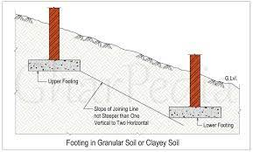We have to obtain adequate information regarding the nature of superstructure and loads to be transmitted on the foundations. To find net safe bearing capacity we have to consider the factor of safety. Both mechanical and physical methods were used to find this model of footings under different loading conditions. Footing dimensions are always modified in such a way that the load becomes concentric to the reduced area.

We must analyse both concentric and inclined loading conditions to the footings so that the following factors can be identified in various locations. For determining the factor of safety of slope shear strength reduction method is widely used. The foundation must be located at such a depth so that it doesn't adversely affect the soil.

### 2.3. Slope Stability /Instability:

Slope failure occurs when the gravity force overcomes the resistance from the shear strength of soil on the surface. Depending on the soil failure mechanism and soil type there are too many conditions that can affect the stability of the soil. These failures can happen due to Rainfall, Erosion, Topography. It has two types of slope stability conditions:

* Finites slopes - Embankments, Dams,Highways,Man-made source/Engineered Slopes
* Infinite Slopes -Mountains, Hills

In finites slopes cracks may occur whereas seepage of water takes place in instability of slopes also can happen in both transverse direction and vertical direction.

#### 2.3.1. Properties of soil:

* Particle size analysis
* Compaction
* Consolidation
* Density Index & Consistency Limits
* Permeability
* Shear Strength

These properties indicate the settlement of structure, stability of foundations, placing of footings. Also, settlement of foundations plays an important role in foundations which are:

* Uniform Settlement
* Differential Settlement

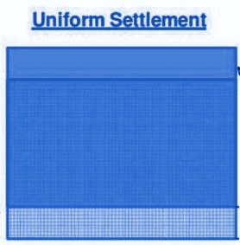 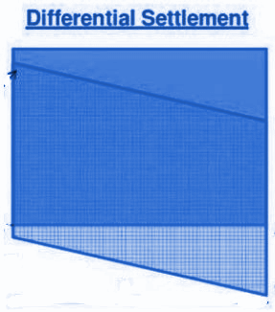

### 2.3.2. Types of Slope failures:

#### Rotational Failure: This usually undergoes finite slope condition, and it has three failures: slope failure, Toe failure, Base Failure.

1. **Slope Failure:** Failure occurs when the failure surface intersects the slope above the toe.

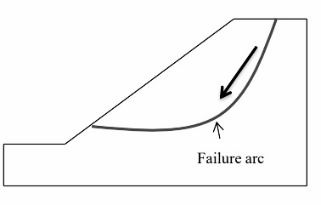

#### Toe Failure: Failure occurs when the failure surface passes through the toe. It is the most common type of failure.

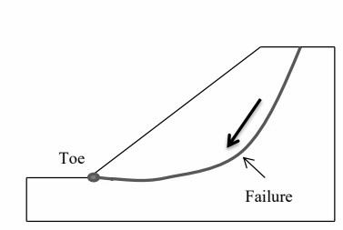

#### Base Failure: Failure occurs when the failure surface passes below the toe. Commonly this failure occurs when soil is weak, and slope is flat.

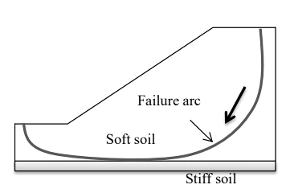

### Translation Failure: This usually undergoes infinite slope condition. This failure occurs along a long surface parallel to the slope. Depends on the shape of the failure surface and depth of the stratum. In transition failure the soil mass occurs failure which comprise of slope homogeneity rather than soil existence within the layer. The mobilized shear strength along the slip surface is depended on the soil strength above the toe surface.

### Compound Failure: This is a combination of both rotational and translational failure types. Occurs when the hard stratum is located at a depth below the toe.

Generally, Slope stability analysis can be performed using limit equilibrium method. Now there are many new approaches & techniques for finding the slope stability analysis. This can be done using effective stress method. But in this method the shear strength of soil has two conditions: drained and undrained. Mohr's-coulomb theory undergoes this type of failure.

## 2.4. 2-Dimensional Slope stability analysis:

It is the common method used for slope grounding surfaces using different approaches in finding the effective stresses and stability conditions. Even for 3-D Slope stability analysis we will convert 3-D to 2-D for easier calculation.

Generally, in Two-dimensional slope stability analysis we follow the Limit Equilibrium Method to find the strength of the soil and failure conditions and stress analysis of finite and infinite slope conditions.

Even for both types of cohesive and Cohesionless soils. In Limit equilibrium Method we divide the soil stratum into slices and non-circular methods. Factor of safety plays a major role.

* Different Methods use different analysis to balance the number of unknowns and number of equilibrium equations.
* Geometry of slope and slip surface plays a major role in lateral directions.

2-D limit equilibrium mainly assumes the failure of slope and plane -strain condition because it reduces the number of unknowns in finding the effective stresses. Depending on the boundary conditions and limitations of shear strength factors the potential failure varies a lot in performing the practical type of application for this advanced method. Therefore, it is important to study this method for performing the limit equilibrium Methods to Finite element methods. The most critical assumptions must be followed for field measurements in particular locations. We can analyse more methods for finding these approaches through FEM (Finite Element Methods).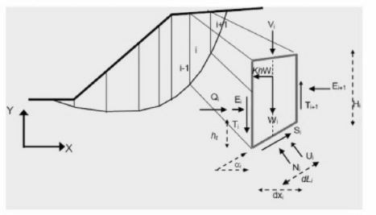

### 2.4.1 Finite Element Method

Finite element method gives more accuracy than the Limit Equilibrium Method in slope stability analysis. Because in Limit equilibrium Method the force and equilibrium moment can't be taken at any point in the soil mass and satisfies in sliding mass only. Even this criterion satisfies for both 2-D and 3-D analysis. Generally, in (LEM) the soil geometry and topography are main cause for stability. But in FEM the geometry and topography on slopes can be performed and analysed. Irregularity geometry and different slip surfaces can also be performed using Finite element Method.

Different thickness of layers and soil profile, geometry and homogeneity properties and distribution of soil type (Grain Size distribution) and factor of safety can be assured to find the stability of the slope condition.

Also, more modification of geometry of slope can lead to decrease in reliability of factor of safety due to limited pre-assumptions. Different soil layers with different properties can incorporate different structural elements. Factor of safety in this method is independent of the stress level and other properties likes modulus of elasticity, depth factors, Poisson ratio and rigidity factor. We can perform this FEM analysis using PLAXIS-2D software which can carry out all the inputs and outputs.

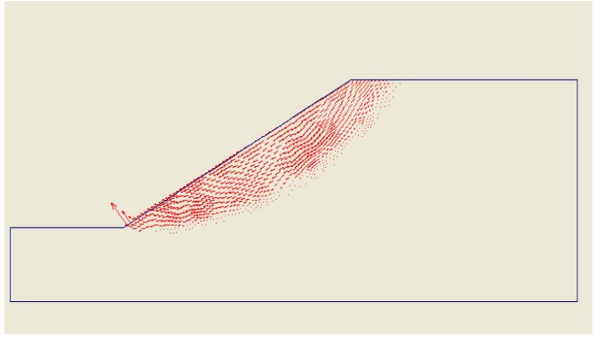

2-D Finite element method: Deformed Slope Condition

### 2.4.2. Factors Affecting the Finite element Method:

* We have to carefully check the boundary conditions while performing the stability analysis.
* It is restricted to linear elastic 2-D plane strain conditions.
* Displacement boundary condition affects the degrees of freedom in a large number of equations.
* In the Finite element method, it is necessary to model both the structure and the soil interface.
* Effective stresses constitute the behaviour of line loads and surface surcharge loading conditions.
* In PLAXIS -2D there are two conditions to be considered in Noded analysis:
* Plain strain
* Axisymmetric

**2.5.Model diagram of isolated strip footing placed near slope:**

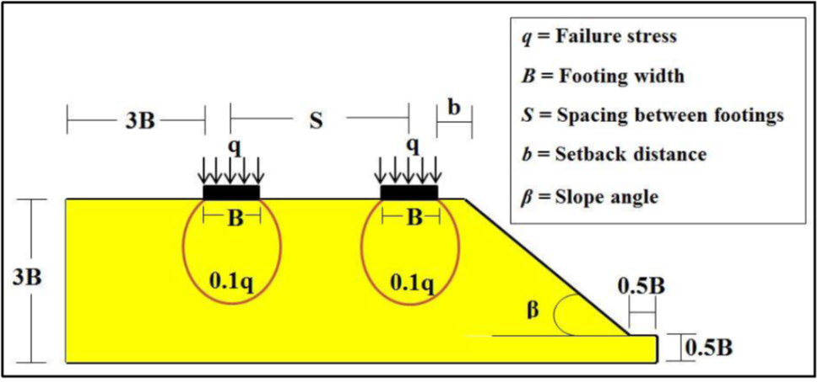

* **Consider c-phi soil:**

1) Angle of Internal Friction (φ) = 30º

2) Cohesion (c) = 20 kPa

3) Young’s Modulus (E) = 20 MPa

4) Dry Unit Weight (γdry) = 18 kN/m3

5) Slope Inclination (β) = 30º

6) Footing width (B) = 1m

7) Embedment Depth of Footing (Df) = 1.0B

8) Setback Distance (b) = 5B

9) Considering Spacing between the footings =2m.

* **Soil Type:**

We have to select the type of soil first to classify it’s all properties. We can set any type of soil and its interfaces. As in the model given cohesion type of soil, we have chosen the clayey type of soil. After classifying the soil properties of the soil should be mentioned .

**Material Properties:**

Considered the type of soil as Clay.

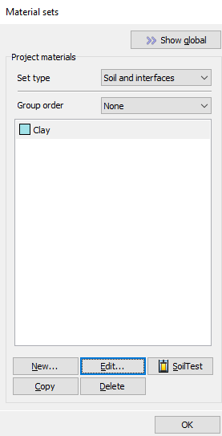

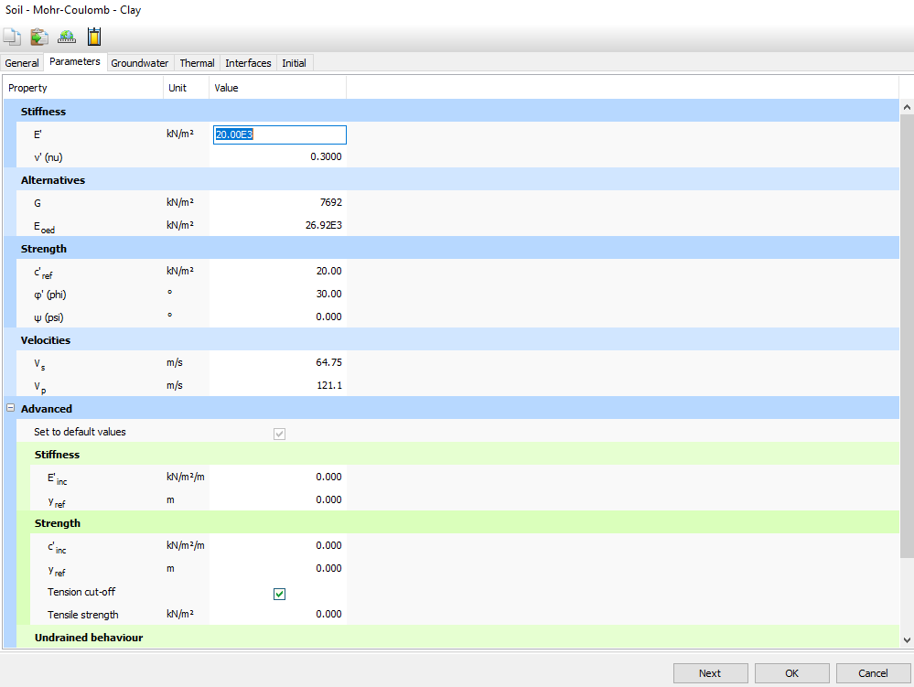**2.5.1. Soil parameters**

**2.5.2. Soil Conditions**

* **Properties of soil:**

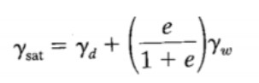(Assuming ‘Void ratio’ e=0.5 , Poisson's Ratio ‘v’(nu)=0.3)

* After placing the loads on the foundation. (Assumed q to be 10 KN/m2):

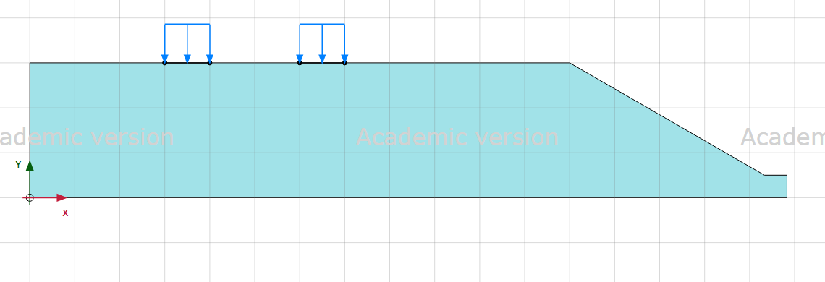

**2.5.3. Designing the sloping soil structure and placing the line load**

* 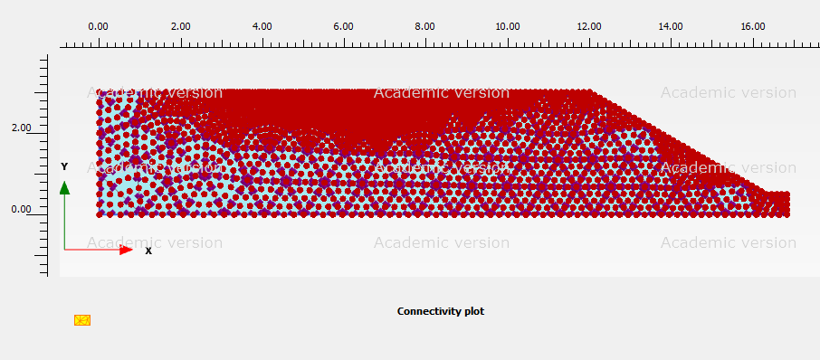**Plot Connectivity of Mesh analysis:**
* **After Generating the Mesh analysis:**

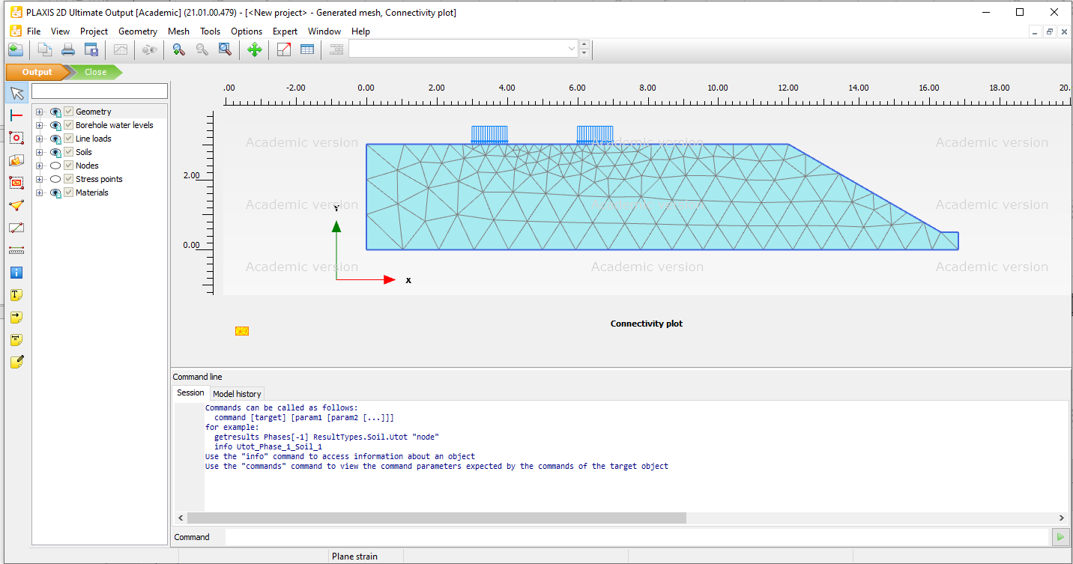

# CHAPTER 3

## Results and Discussions

**3.1. Table with the calculated the stress, strain, deformed mesh and Msf (Factor of safety)**

* Implemented with different sets of combinations:
* Checking all the conditions with different Values and Parameters:

The initial phase, phase 1 (plastic phase), and phase 2 (factor of safety phase) are all part of the staged construction process, and each phase requires calculations.

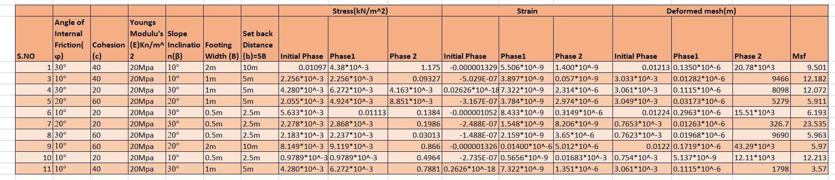

* Initial Phase- Static Condition
* Phase1-Plastic Condition
* Phase 2- Factor of Safety

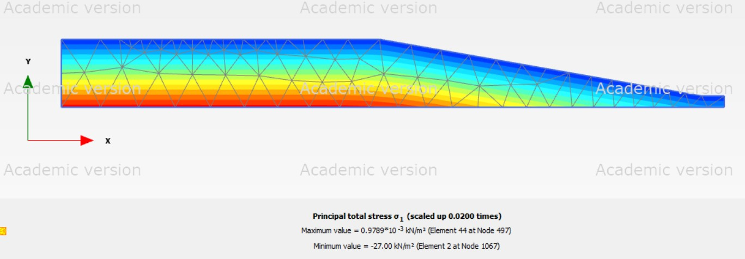

**3.2.Principle Total Stresses**

**Above New Structure Parameters:**

1) Angle of Internal Friction (φ) = 10º

2) Cohesion (c) = 20 kPa

3) Young’s Modulus (E) = 20 MPa

5) Slope Inclination (β) = 10º

6) Footing width (B) = 0.5m

8) Setback Distance (b) = 5B

9) Considering Spacing between the footings =2m.

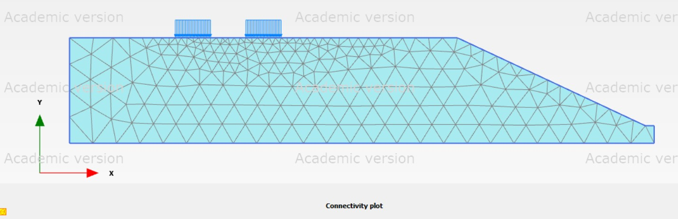**Dimensions:**

After Generating Mesh

(i) B=2m

S=2m

b=5B=10m

**3.3. Connectivity Plot**

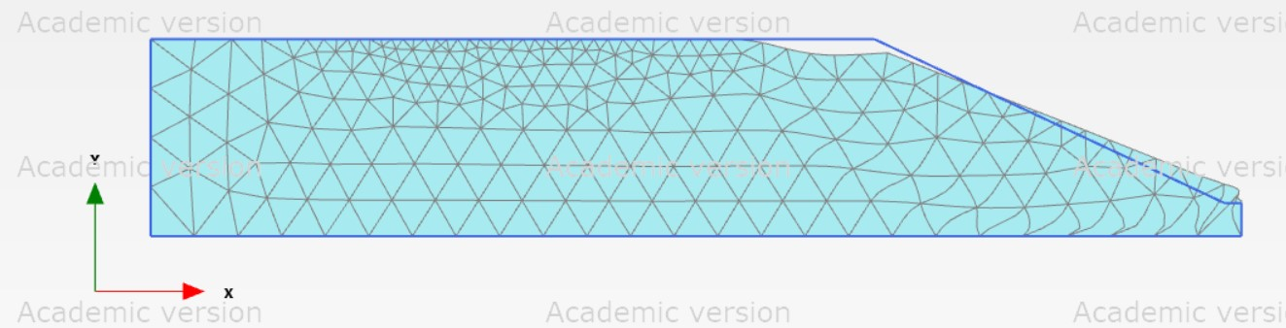**Output:**

**3.4. Load Principal Deformed Mesh**

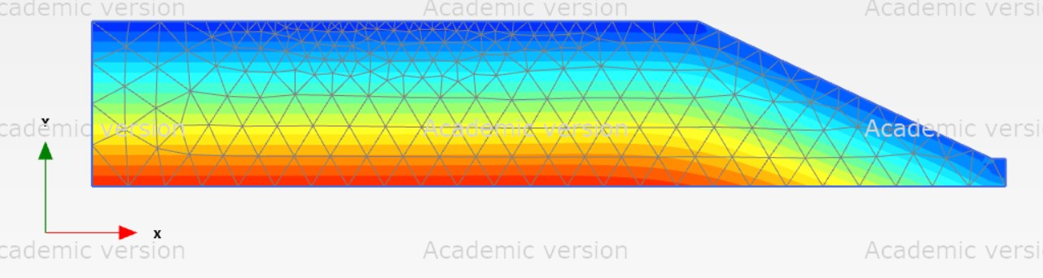

**3.5. Stress Distribution:**

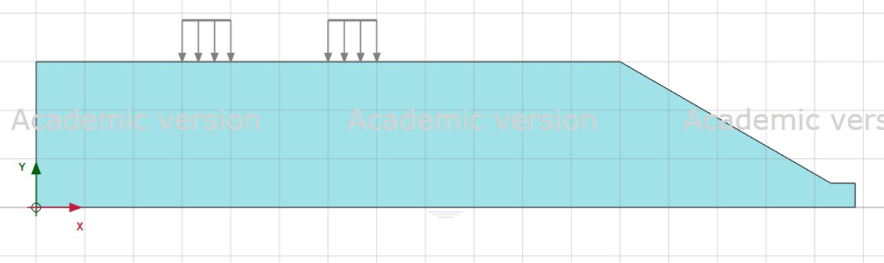

(ii) B=1m

S=2m

b=5B=5m

**3.6. Distribution of Load**

**Output:**

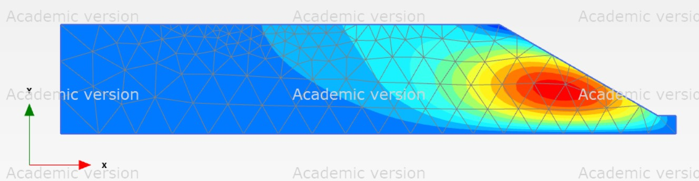

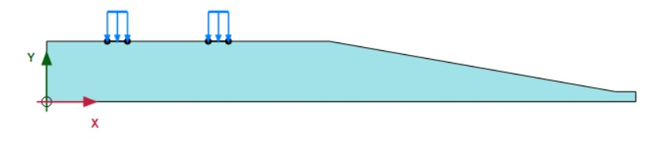(ii) B=0.5m

S=2m

b=5B=2.5m

**3.7. Structure Load**

**Output:**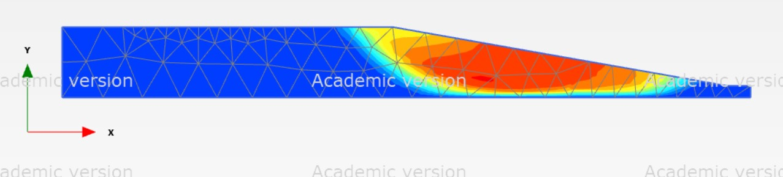

**3.8. Pressure Bulbs**

**3.2. In PLAXIS-2D**

* Boreholes are the place in the structure component to specify the given information on the positions of soil layers. For suppose if multiple boreholes are given PLAXIS-2D will interpolate automatically between the mentioned boreholes. Distribution of layers are kept horizontal. Many factors that influence the load bearing capacity and factor of safety of the structure can be considered using this software.
* For behaviour of the soil the soil properties and material parameters should be mentioned to the given geometry. In PLAXIS-2D soil properties are collected in materials data sets for some of the fixed parameters. Geometry model does not include the interfaces and default conditions.
* After completion of the model finite element mesh must be done. PLAXIS-2D allows for a fully mesh generation procedure. It consists of different element distributions:
* Medium
* Fine
* Coarse
* Very Fine
* Very Coarse

**3.2.1Graphs:**

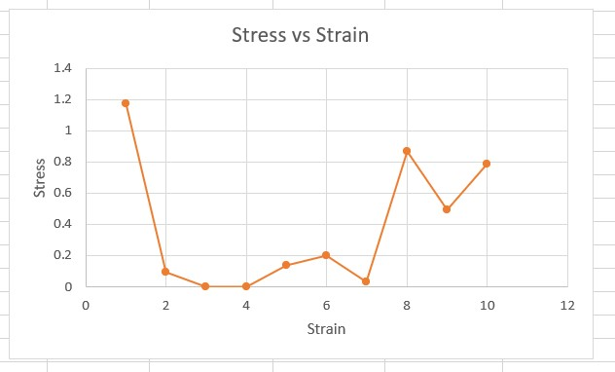

**Stress vs Strain**

**3.3. Factor of Safety:**

A slope is considered unstable when the factor of safety is less than 1.0. If factor of safety were a deterministic variable, a slope would be classified as stable if it had a value greater than 1.0. We can conclude that all of the conditions are safe based on the Msf (factor of safety) values reported above. The variables used to calculate the factor of safety, such as the method of analysis, the physical and mechanical qualities of the ground, ground geometry, and so on.

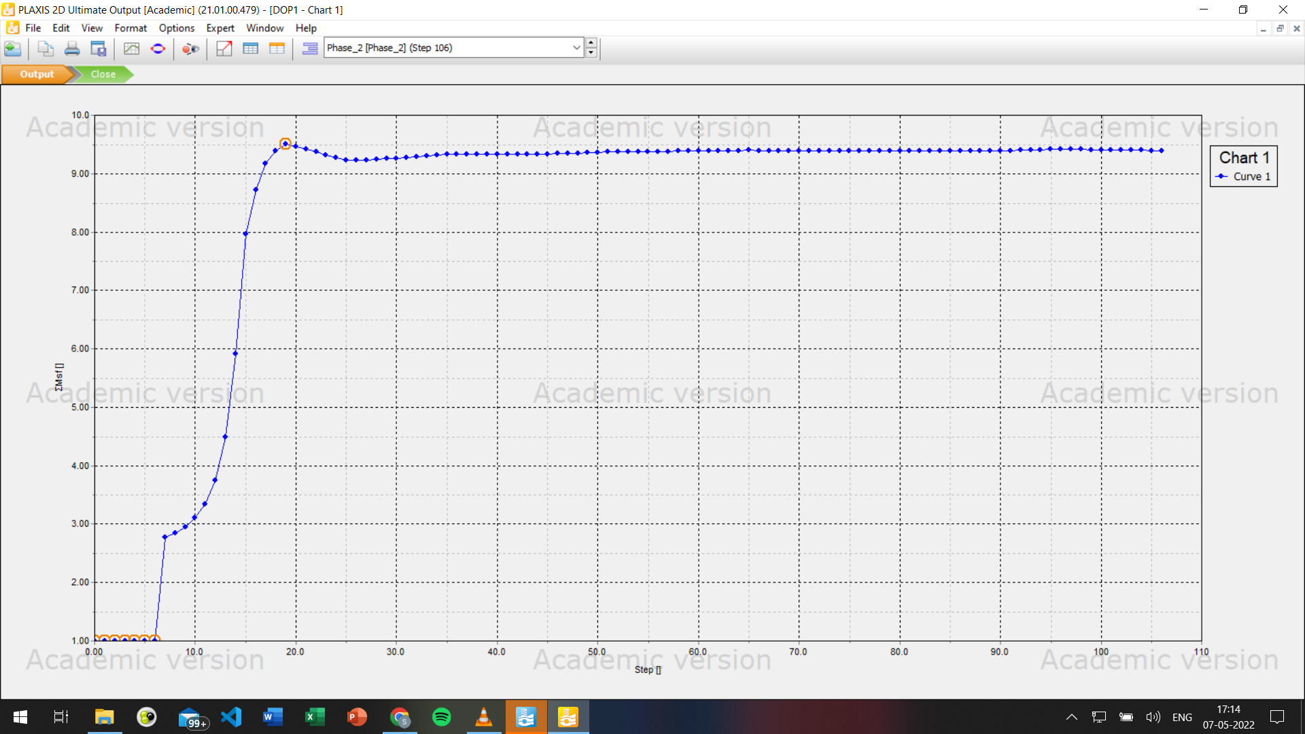

**3.3.1. Factor of safety curve**

All impose some error in the final value, and a probabilistic review can be used to estimate a confidence interval for the factor of safety. In this probabilistic model, the question is no longer whether a slope is stable or not. Many elements influence the carrying capacity and safety factor of the soil, including the type of soil, the level of the water table, the effect of tension cracks, the slope of the ground, the distance of the footing from the slope, and the kind of footing.

**3.3.2. Factor of Safety Vs Slope Inclination**

# CHAPTER 4

## Conclusions

**4.1. General**

From the table we can see that the value of Factor of Safety is greater than 1 in all the conditions which means the structure is safe in the minimum permissible limits. As we have tried many conditions and combinations to get the Factor of Safety for the structure to sustain the load. Highest and lowest values of Factor of Safety (FoS) are 23.52 and 3.57 as their dimensions and spacing we provided on assumption.

|  |  |
| --- | --- |
| **1** | **2** |
| Angle of Internal =20º | Angle of Internal =10º |
| Cohesion (c) = 20 kPa | Cohesion (c) = 40 kPa |
| Young’s Modulus (E) = 20 MPa | Young’s Modulus (E) = 20 MPa |
| Slope Inclination (β) = 30º | Slope Inclination (β) = 30º |
| Footing width (B) = 0.5m | Footing width (B) = 1m |
| Setback Distance (b) = 5B | Setback Distance (b) = 5B |
| Considering Spacing between the footings =2m. | Considering Spacing between the footings =2m. |
| Factor of Safety=**23.53** | Factor of Safety=**3.57** |

Also, the bearing capacity of the load plays a major role in the calculation of Factor of safety.

**Factor of safety=Ultimate Load (Strength)/Allowable Load (Stress)**

**4.2. Summary**

During this project, numerous errors occurred, most of them were related to the simulation process in the end. More critical conditions can be taken under consideration for better understanding of the model. We used to get an error saying that the strength reduction factor and the soil layers are not connected during the staged construction process after all the parameters and values were submitted due to embedment depth in the structure being very small, later it has been changed and processed.

**References**

**Author – Date System:**

Dawson, E. M., Roth, W.H. and Drescher, A. (1999) Slope Stability Analysis by Strength Reduction. Geotechnique, Vol. 49, No. 6, pp. 835-840.

Duncan, J.M. and Wright, S.G. (2005) Soil Strength and Slope Stability, John Wiley & Sons, Inc., Hoboken, NJ .

Fredlund, D. G., and Krahn, J. (1977) “Comparison of Slope Stability Methods of Analysis,” Canadian Geotechnical Journal, Vol. 14, No. 3, pp. 429-439.

Griffiths, D.V., and Lane P.A. (1999) Slope Stability Analysis by Finite Elements, Geotechnique, Vol. 49, No. 3, pp. 387-403

Matsui, T., San, K. (1992). “Finite element slope stability analysis by shear strength reduction technique.” Soils and Foundations, 32(1), 59-70.

Morgenstern, N. R. and Price, V. E. (1965) The analysis of the stability of general slip surfaces, Geotechnique, Vol. 15, No.1, pp. 79-93.

Nguyen, V.u. (1985). “Determination of critical slope failure surfaces.” Journal of Geotechnical Engineering, ASCE, 111(2), 238-250.

Sarma, S. K., (1973) “ Stability Analysis of Embankments and Slopes.” Geotechnique, Vol. 23, No. 3, pp. 423-433.

Wei, L., Koutnik, T., and Woodward, M. (2010) A slope Stability Case study by Limit Equilibrium and Finite Element Methods. GeoFlorida 2010: Advance in Analysis, Modeling & Design, pp. 3090-3099